SHIP SANITATION CERTIFICATE CHARGES 1ST APRIL 2021 – 31ST MARCH 2022
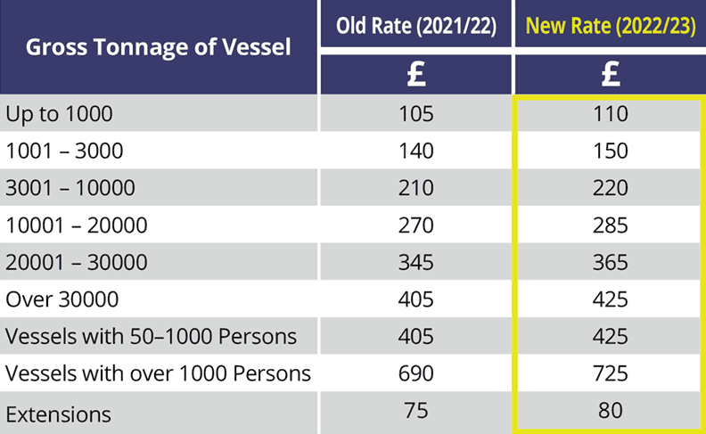

Bacteriological Water Samples: £50 per sample
Legionella Water Samples: £95 per sample

