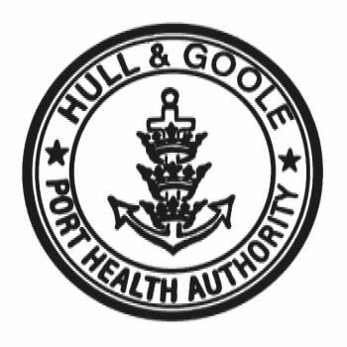
HULL & GOOLE PORT HEALTH AUTHORITY



GENERAL ENFORCEMENT POLICY

General Statement
The Authority’s enforcement policy helps to promote efficient and effective approaches to regulatory inspection and enforcement, which improve regulatory outcomes without imposing unnecessary burdens. This is in accordance with the Regulators’ Compliance Code.
In certain instances we may conclude that a provision in the Code is either irrelevant or is outweighed by another provision. We will ensure that any decision to depart from the Code will be properly reasoned, based on material evidence and documented.
The aim of this booklet is to advise businesses and other service users what they may expect from the Authority’s enforcement officers (Environmental Health Officers) and the decision framework applied by the Authority in deciding what, if any, of its powers to exercise in enforcing legal provisions.
Policy
The Hull & Goole Port Health Authority
- Has regard to the Regulators’ Compliance Code and will assist and encourage regulated entities to understand and achieve compliance with legal requirements more easily; and respond proportionately to identified regulatory breaches.
- Takes into account guidance set out in the Code for Crown Prosecutors.
- Recognises that where there is a shared enforcement role with other authorities and enforcement bodies it has in place arrangements to promote co-operation and consistency.
- Takes into account the needs of all stakeholders within its area, including businesses, employees and the public.

Frequently Asked Questions

- Who will visit my premises?
- Authorised officers have a right to enter and inspect business premises, including ships, at all reasonable hours. They do not have to make an appointment and may visit without notice.
- Officers must give at least 24 hours notice before requiring entry to domestic premises.

- What will they look for?
- Officers will concentrate on priorities, but will also deal with any other matters of concern, when carrying out inspections and investigations.
- They will look for breaches of the relevant law by interviewing managers, ships officers, and staff.
- They will inspect premises, including ships, observe activities and examine documentation.
- They will assess the effectiveness of management in identifying hazards and in controlling the risks arising from activities.
- They will look for bad practices and provide advice and guidance on best practice.

- How often will my premises be visited?
- The frequency of planned inspections of land-based premises will depend on the risk-rating of your premises. This takes account of factors such as hazards, previous history and confidence in management.
- Ships will be visited according to a risk-assessment or as a result of a service request or complaint.
- Premises may also be visited as part of a special survey or as a result of complaint or other incident.

- What can I expect from the officers?
- To be shown identification.
- To be treated courteously.
- To be able to discuss the outcome of the inspection or visit and to receive advice and guidance.
- To receive a report of the inspection detailing any breaches of the law, with a clear distinction being made between recommendations and any action necessary to comply with the law.
- To be given an appropriate timescale to take any action necessary to comply with the law.
- To be informed of any likely follow-up action.
- To be allowed to discuss any relevant circumstances before any formal enforcement action is taken, unless immediate action is required.
- To be given reasons for immediate action at the time it is taken and to receive written confirmation within 10 working days.
- To be notified in writing of any rights of appeal against formal action at the time it is taken.

- What powers do officers have and what action will they take?
- Officers have powers of entry (see 1. above).
- They may carry out investigations and examinations; take measurements, photographs and samples.
- Detain or seize food, defective equipment and articles.
- Require information and take statements from people they believe can assist in an investigation.
- Inspect and copy documents.
You must not obstruct officers in carrying out their duties. It is an offence to do so.
Officers may
1. Take no formal enforcement action when the premises are found to be satisfactory, this will be confirmed in writing.

2. Take informal enforcement action when there are no serious breaches of the law and:
- It is considered that such informal action will be successful
- Confidence in management is high
- It is considered that taking informal action will have the same effect as taking formal action
- Officers will send informal letters, give verbal warnings and requests, offer advice and issue reports of inspections.
3. Take formal enforcement action
- By serving a Fixed Penalty Notice in the case of smoke-free law being breached by smoking in a smoke-free place or failure to display correct no-smoking signage.
- By serving an Improvement Notice or Abatement Notice when, in the officer’s opinion, legislation has been breached and :
There is a lack of confidence in management, or there is a history of non-compliance with informal action, or where conditions are serious and deteriorating and a prosecution may follow.
An Improvement Notice or Abatement Notice will specify what is wrong, what remedial action is necessary and give an appropriate timescale to take any action to comply with the law. Failure to comply with an Improvement Notice or Abatement Notice is a serious offence and is likely to lead to prosecution.

- By serving a Prohibition Notice when, in the officer’s opinion, there is a serious or imminent risk to health.
A Prohibition Notice will specify the risk, what legislation has been contravened and direct that the activity shall cease until the risk is removed. If there is imminent risk the Notice will take immediate effect and stop the activity at once.
Failure to comply with a Prohibition Notice is a serious offence and is likely to lead to prosecution.

- By seizing food, dangerous articles or substances when, in an officer’s opinion, there is a cause of imminent risk to health.
If appropriate, a sample will be taken and a portion left with a responsible person.
The food etc may be destroyed at the owner’s expense.
A written report will be prepared and signed by the officer, explaining the action taken and why.

- By Prosecuting offenders when, in an officer’s opinion, an offence has been committed and there is sufficient evidence to initiate a prosecution. The officer shall take into account a number of factors in accordance with the Code for Crown Prosecutors before deciding to prosecute. These factors may include;
- The seriousness of the alleged offence
- The history of the business or individual
- The willingness of the business or individual to prevent a recurrence of the problem and co-operate with officers
- Whether it is in the public interest to prosecute
- The likelihood of a prosecution succeeding
- Whether any other action (including a simple caution) would be more appropriate or effective.
- These factors are not listed in order of priority or significance and their rating will vary with each situation.
- The final decision to prosecute offenders rests with the Chief Port Health Inspector in consultation with The Clerk to the Authority and with regard to the Regulators’ Compliance Code.
- By issuing a Simple Caution when under normal circumstances a prosecution may be warranted but a prosecution is not in the public interest or the person responsible is prepared to accept a simple caution.

- What rights of appeal are there against Statutory Notices or other Formal Action?
- You will be notified in writing of any rights of appeal at the time the action is taken.

- What if I do not agree with the action taken and want to complain?
- You will need to contact the officer directly, stating why you do not agree and any proposed alternative action.
- If you are still not satisfied:
- Contact the Chief Port Health Inspector who will deal with your complaint formally.
- We will send you a written acknowledgement explaining what will happen.
- Your complaint will be investigated and you will be contacted with the outcome within 2 weeks.
- If you remain not satisfied you may address your complaint to the Clerk to the Authority who may refer your complaint to the Board of Elected Councillors.
- If you are not satisfied that your complaint has been dealt with through the stages listed above you may refer your complaint to the Local Government Ombudsman. This is an independent organisation an the contact details are as below;

The Local Government Ombudsman
PO Box 4771, Coventry, CV4 0EH
Tel: 0300 0614
www.lgo.org.uk

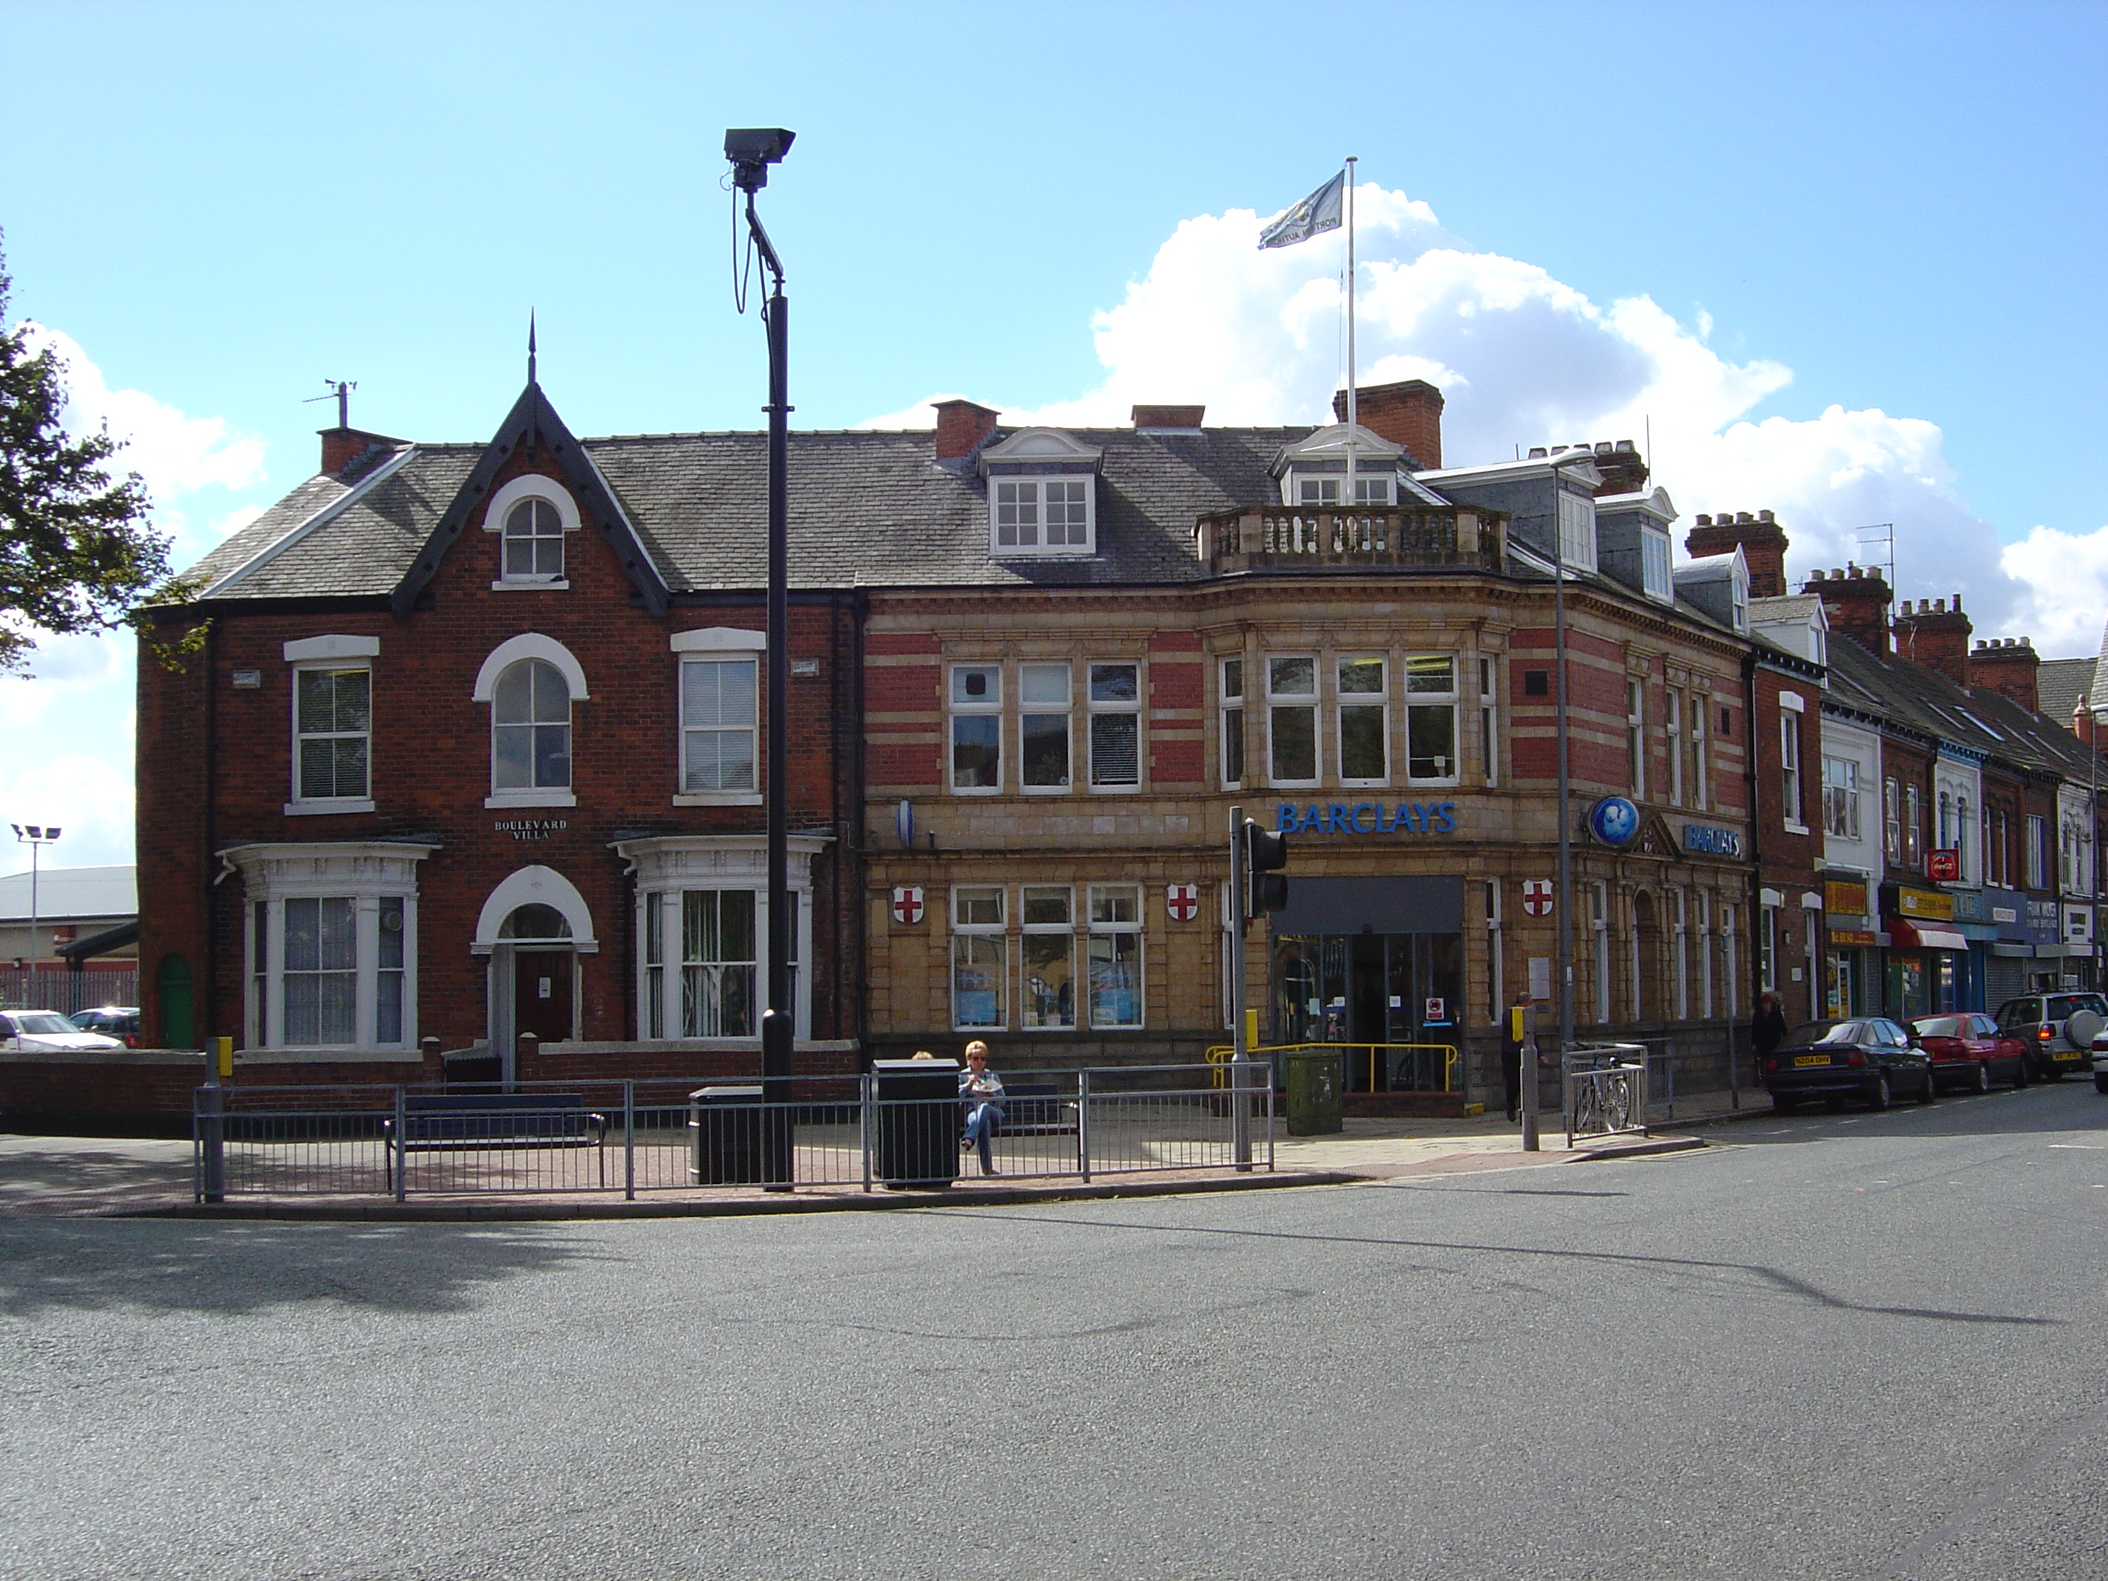
The Chief Port Health Inspector,
Hull & Goole Port Health Authority,
257 Hessle Road, Kingston upon Hull, HU3 4BE
(above Barclays Bank)
Tel: 01482 324776 Fax: 01482 219275
Email: admin@hullandgoolepha.gov.uk
Website: www.hullandgoolepha.gov.uk

